# Windows drive encryption detection

# Preparation (on standalone machine)

1. Download Magnet Encryption Drive Detector. It can be obtained in one of the following ways and is free to use:
   1. Vendor website: [www.magnetforensics.com](http://www.magnetforensics.com). It is necessary to provide contact details to download software, but the download starts after submitting the form.
   2. Download a copy from IBM X-Force IRIS Cloud Storage: https://ibm.box.com/v/EncryptionDriveDetector-IRIS
2. Find removable storage media: it will be formatted and data may be irrecoverably lost!
3. Prepare removable media:
   1. Format the media (quick format is sufficient) using NTFS or ExFAT filesystem.
   2. Copy above software onto the media.

# Information capture (on target machine)

It is required is to have administrative rights on the machine.

1. Connect prepared previously removable media.
2. Launch Magnet Encryption Drive Detector
3. Accept “End User License”
4. Following window will be show. Let the tool run until “Press any key to continue…” will be presented.
5. Do not close the window. Take a physical note about type of encryption present in the system, by checking message “PhysicalDriveX contains a <ENCRYPTION_TYPE> encrypted volume.” Example of such message is show in the image below (marked in the red rectangle): 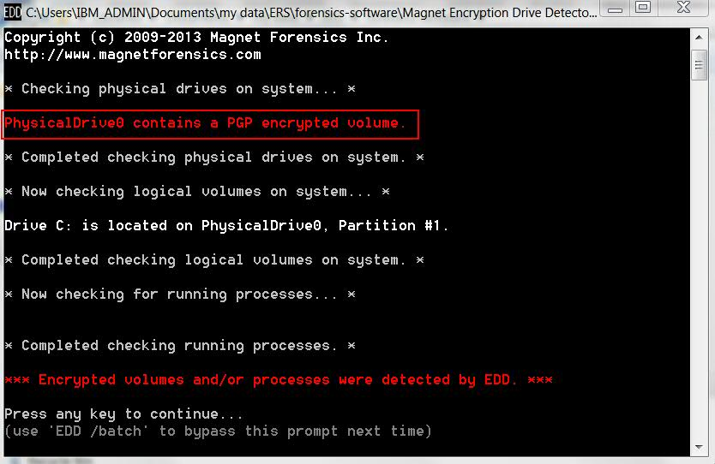
6. In case of no encryption, following message will be show: “No (…) encrypted volumes detectable by EDD were found.”
7. When completed, close application and safely disconnect media from the system.
8. Send information about encryption to designated IBM X-Force IRIS Consultant.